Assignment 1A

What is the maximum current the Arduino can provide via V CC ? - 450 mA on a normal USB port, but it depends on the current provided by the USB.

What is the maximum current the Arduino can provide via digital output? - 40 mA, but it is advised not to exceed 20 mA.

What is the maximum current the Arduino can drain via GND? - As much as the microcontroller needs to function properly – which is around 40 mA.

What is the voltage range that the Arduino sees as HIGH on digital input pins? - 60% of the operating voltage, so 60% of 5V is 3V and more.

What is the voltage range the Arduino sees as LOW on digital input pins? - Anything less than 3V.

What is the voltage range the Arduino outputs as HIGH on digital output pins ? - A little bit less than 5V.
What is the voltage range the Arduino outputs as LOW on digital output pins? - 0V.

What is your conclusion when you see these specs? - The Arduino is not suitable to power high-power demanding modules.

What is the maximum forward current (II FF ) of the LED? See datasheet. - 20 mA by datasheet.

What is the forward voltage (UU FF ) across the LED at the current? See II FF − UU FF graph in the datasheet. - 2V given I = 20mA.

11. Use Ohm’s law and Kirchhoff’s laws to calculate the series resistor R for the
maximum II FF and UU FF . Show your calculations (formula’s and results) and your
reasoning with meshes and nodes. - We need a 100 Ohm resistor for max If and Uf.
LED1 : U = I.R | 2 = 0,02.R | R = 2/0,02 | R = 100 Ohms - https://git.fhict.nl/technology/edures/blob/master/level-1/Embedded-Systems/hardware-track/Datasheets/LED%20Red%205mm.pdf
LED2: U = I.R | 3 = 0,03.R | R = 3/0,03 | R = 100 Ohms - https://git.fhict.nl/technology/edures/blob/master/level-1/Embedded-Systems/hardware-track/Datasheets/LED%203mm%20datasheet.pdf

12. Recalculate the resistor for this safety limitation. You will use this “safe” resistor
in the next step. Show how you calculated the values (formula’s and results). - For the 2nd LED, we will need a 100 Ohm resistor.
LED2: R = 2/0.02 = 100 Ohms

13. If the resistor value is not a standard resistor in the E3 series, then can you
create this resistor using standard resistors in the E3 series? Explain your answer
and show the calculations. - These resistor are wide spread and available everywhere, but if we wanted to create a resistor with a custom value, we would need to connect (in series) a few resistors with value that add up to the desired value.
Now build the circuit with the “safe” resistor and use V CC of the Arduino as the power
supply (5V).
14. Measure V CC (UU), the voltage drops over the resistor (UU RR ) and the LED (UU FF ), and
measure the current (II) in the circuit. Explain the measurements. VCC – 4.99V, the V drops with 3.14V. Forward Voltage of LED is 1.86V. Current passing trough the LED is 30 mA.

15. Are the measured values equal to the calculated and datasheet values? Explain. - The values are a little higher than the calculated one. (Later found out a wrong resistor was used, but do not have any resistors at home so I cannot do the proper circuit. I think I used a 1k Ohms resistor by a mistake.).

Now we are going to determine the resistor value needed for the night mode. The light
emitted by the LED has no linear relationship with the current; e.g. reducing the current
by 2 does not reduce the brightness by half. Therefore, we have to experiment with
different resistor values until the LED brightness is suitable for the night mode.

16. Determine the resistor value for night mode. Explain the steps. - The resistor will be 2k Ohms.

17. What is the voltage (UU FF ) across the LED at the forward current for night mode? - 1.77 Vf

18. What is the forward current (II FF ) through the LED for night mode? - 1.7 mA

19. Compare these measured values with the characteristics in the datasheet, and
proof that this is correct using Ohm’s law and Kirchhoff’s law. Explain your
answer and show the calculations. - By datasheet information this is correct.

U = I*R | I = U/R | I = 3.4 / 2000 | I = 1.7 mA
Assignment 1B

How can you determine the cathode or anode of the LED? - the anode is usually the longer leg. If there is no longer leg, then you should check for a flat part on one side of the LED, this is the minus. If there is still no sign for + or -, you can see the LED itself (inside the plastic shelf) – the bigger part should be the cathode.

What is the wavelength of the emitted light? - By datasheet information – In it’s highest intensity – 640 nm. (But depends which LED)

Why do we need a resistor in series with the LED? - Since if we do not put a resistor we are basically going to short the circuit. The LED has nearly 0 resistance.

What is the forward voltage and what is the reverse voltage? - The forward voltage is the voltage flowing trough a normally connected LED (+ to – and – to +). The reverse voltage is when the LED is connected with reversed polarity (+ to + or – to -).

What is the maximum reverse voltage of the LED? The max reverse voltage is 6V.

What will happen to the LED when the reverse voltage exceeds the maximum
reverse voltage? - It will overload and not work anymore.

7. Can you make any statements on the amount of light emitted by the LED
during daytime mode? - It is the maximum possible light emitted with a “safe” resistor. Some more light might be squeezed out of the LED but the real-world Voltage and current might not exactly match the in-theory Voltage and Current, so we keep it on the safe side.

Assignment 1C
Lets look at some characteristics of the LED. In assignment 1A we used the Arduino as a
5V power source. Let’s use a 12V desktop power source.

1. Why can’t we use the circuits for daylight and nightlight from assignment 1A
with 12V? Explain your answer. Give proof by calculation. - If

2. Recalculate the daytime resistor using the 12V power supply. - 600 Ohms.

Build the circuit with the new resistor, the LED and the 12V desktop power supply. Use
the voltage range 0-12V. Start at 0V and slowly turn it up until 12V.

3. Determine when the LED starts to conduce current. Explain the process. - at around 1.5V, this is when the LED gets current enough to light up just a little bit.

4. Write down the voltages (UU FF ) and currents (II FF ) for each step and draw a plot
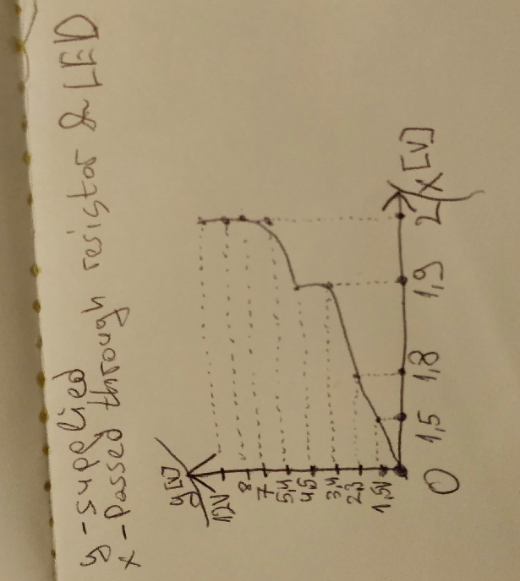
that shows the II FF − UU FF characteristics of the LED. Explain the plot. - The higher the voltage, the higher the current (limited by resistor).
Supplied – Passed trough resistor & LED
1.5V – 1.5V
2.3V – 1.8V
3.4V – 1.9V
4.5V – 1.9V
5.4V – 2V
7V – 2V
8V – 2V
12V – 2V
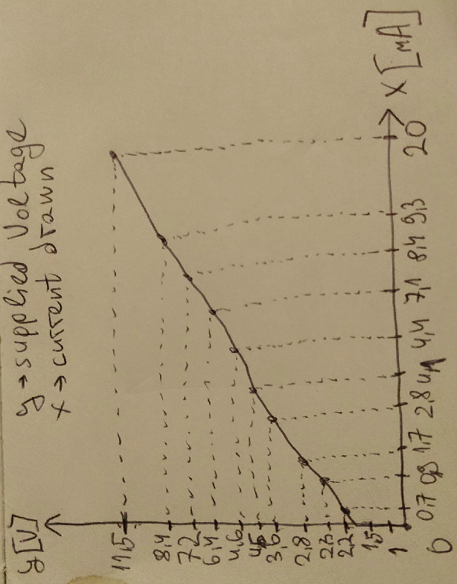
Supplied Voltage [V]– Used current [A] by LED and passed trough resistor
1V – 0A
1.5V – 0.A
2.2V – 0.7 mA
2.3V – 0.9mA
2.8V – 1.6-1.7mA
3.6V – 2.8 mA
4.5V – 4.1-4.2mA
4.6V – 4.4 mA
6.4V – 7.1mA
7.24 – 8.4 mA
8.4V – 9.0- 9.3 mA
11.5V – 20 mA
Tip: Use sufficient steps so that the plot is accurate enough.
Reverse the power supply to generate -1V and -4V.

5. Measure the current for -1V and -4V thought the circuit and explain the
values found using the datasheets. - 0mA on -1V, 0mA on -4V – Since the max reverse Voltage of the LED is 6V.

6. What does the datasheet say about the reverse characteristics? - If the reverse voltage exceeds 6V the LED is going to get burned.

Assignment 1D
Now we are going to toggle between day and night mode using the Arduino with one
button and two LED’s. Resistor R 2 is used for daytime mode and it is determined in
1.13. Resistor R 3 is used for nighttime mode and it is determined in A1.17. Resistor R 1
is 10kΩ.

1. Make an Arduino program that switches between modes every time you push
the button. Uploaded in the folder of Week 2 Assignment.

Buttons and switches are bouncing by nature. This is a serious problem for reading the
state of the buttons or switches in software.

2. What is bouncing and what is causing bouncing? - Bouncing is basically the voltage jumping from HIGH to LOW and vice versa in a quick manner when a button is pressed. It is caused by the non-instant touch of the two metal surfaces. To users it might seem as it is instant, but in fact in the matter of a few milliseconds the two surfaces change their “state of touching each other” due to physical imperfections.

We can implement debouncing in software using
https://www.arduino.cc/en/Tutorial/Debounce
as we have already used in ES1. We can also use a library
http://www.arduino.cc/playground/Code/Bounce

3. Add this library and use it in your program and give a short description (in your
own words) of the different library functions.
Bounce()– creates a new “debouncer” object.
Void interval – determines how often the button is going to be read – in other words must be higher than the “bouncing” period of the button, which is typically around 10-20 ms (50ms is a safe pick).
Void attach() - attach to the desired pin (pin of the button)
bool update – This simulates a statechange machine. Figures out whether or not there was a change in the state of the button from the last loop.
Bool read – gives the buttons value (true or false)
bool fell – returns true if button’s state changes from HIGH to LOW
bool rose – returns true if button’s state changes from LOW to HIGH
The library mentioned above is working on the millis() principle. It is using the internal clock to determine time passed between the different readings of the button.

I personally prefer to use my own Debouncing solution (As well as my own state-change machine), which is fundamentally the same but is directly implemented into the code, without using any libraries or whatsoever.

